报修项目中英文对照

Repair project Chinese-English comparison
水 water | 上水  up water | 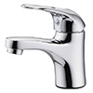  龙头坏  tap broken
水 water | 上水  up water | 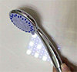  蓬头坏  shower nozzle broken
水 water | 上水  up water | 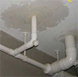  水管漏水  water pipe leaking
水 water | 上水  up water | 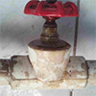  阀门坏  valve broken
水 water | 上水  up water | 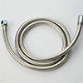  软管坏  soft pipe broken
水 water | 下水  down water | 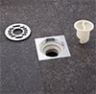  卫生间堵  toilet stuck
水 water | 下水  down water | 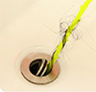  水池堵  sink stuck
水 water | 下水  down water | 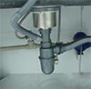  下水管道漏水  sewer pipe leaking
水 water | 下水  down water | 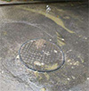  室外主下水堵  outdoor main pipe stuck
电 electricity | 照明  light | 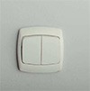  开关坏  switch broken
电 electricity | 照明  light | 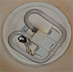  灯管坏  light broken
电 electricity | 照明  light | 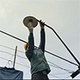  路灯坏  streetllight broken
电 electricity | 插座  socket | 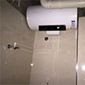  热水器插座坏  heater socket broken
电 electricity | 插座  socket | 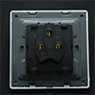  空调插座坏  air condition broken
电 electricity | 插座  socket | 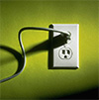  插座没电  socket no electricity
电 electricity | 空开  air switch | 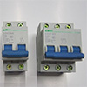  空开坏  air switch broken
电 electricity | 电风扇  fanner | 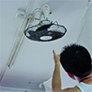  风扇坏  fanner broken
电 electricity | 电风扇  fanner | 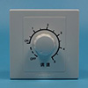  风扇开关坏  fanner switch broken
家具 furniture | 门窗  door and window | 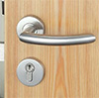  门锁坏  door lock broken
家具 furniture | 门窗  door and window | 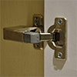  铰链坏  hinge broken
家具 furniture | 门窗  door and window | 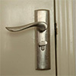  把手坏  door handle broken
家具 furniture | 门窗  door and window | 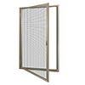  纱窗坏  screen window broken
家具 furniture | 门窗  door and window | 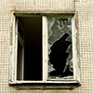  玻璃坏  glass broken
家具 furniture | 门窗  door and window | 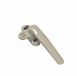  拉手坏  window handle broken
家具 furniture | 床  bed | 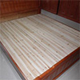  床板坏  bed board broken
家具 furniture | 床  bed | 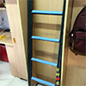  爬梯坏  ladder broken
家具 furniture | 床  bed | 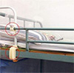  护栏坏  bed guardrail broken
家具 furniture | 床  bed | 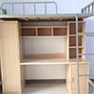  床晃动  bed shaking
家具 furniture | 衣柜  cupboard | 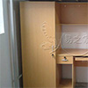  衣柜门坏  cupboard door broken
家具 furniture | 衣柜  cupboard | 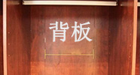  后背板坏  back board broken
家具 furniture | 衣柜  cupboard | 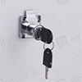  抽屉锁坏  drawer lock broken
家具 furniture | 衣柜  cupboard | 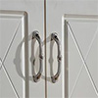  柜门拉手坏  cupboard handle broken
家具 furniture | 衣柜  cupboard | 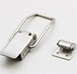  柜门搭扣坏  cupboard buckle broken
家具 furniture | 衣柜  cupboard | 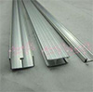  轨道坏  rail broken
家具 furniture | 衣柜  cupboard | 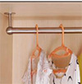  衣柜挂衣杆坏  hanger rod broken
家具 furniture | 桌椅  desk and chair | 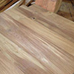  桌板坏  desk broken
家具 furniture | 桌椅  desk and chair | 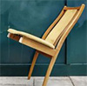  椅子坏  chair broken
家具 furniture | 桌椅  desk and chair |   桌子需要焊接  desk needs weld
家具 furniture | 窗帘  curtain | 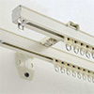  轨道坏  rail broken
家具 furniture | 窗帘  curtain | 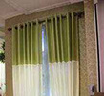  布坏  cloth broken
Other  其他 | 路牙  curb | 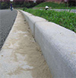  路牙坏  curb broken
Other  其他 | 路面  road surface | 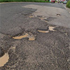  路面坑洼  road potholes
Other  其他 | 窨井盖manhole cover | 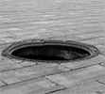  缺少盖子  lack of cover
Other  其他 | 消防水  firewater | 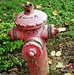  消防栓坏  fire hydrant broken

Intellgent Repair Service English Interface
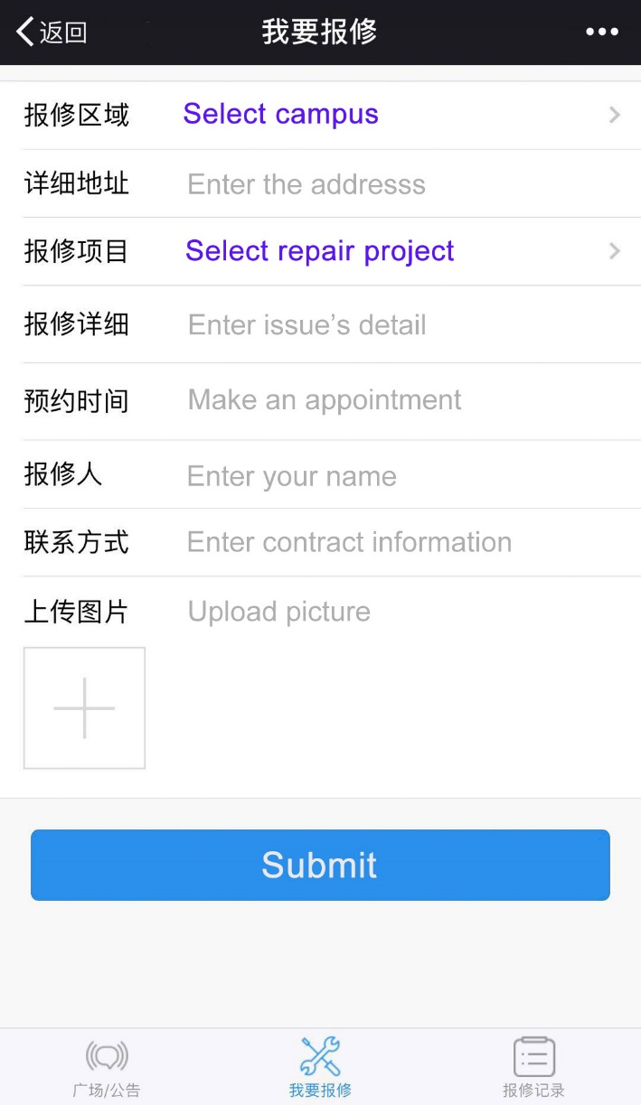

Tips:
- If you cannot find your problem in ‘报修项目’, please select other and enter details in ‘报修详细’.
- Normally, if you have problem in your dorm, please select ‘江浦校区’> ‘宿舍楼’> ‘其他’, then fill overseas students dormitory room XXX in ‘详细地址’.

